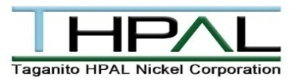

THPAL PROCESS FLOW

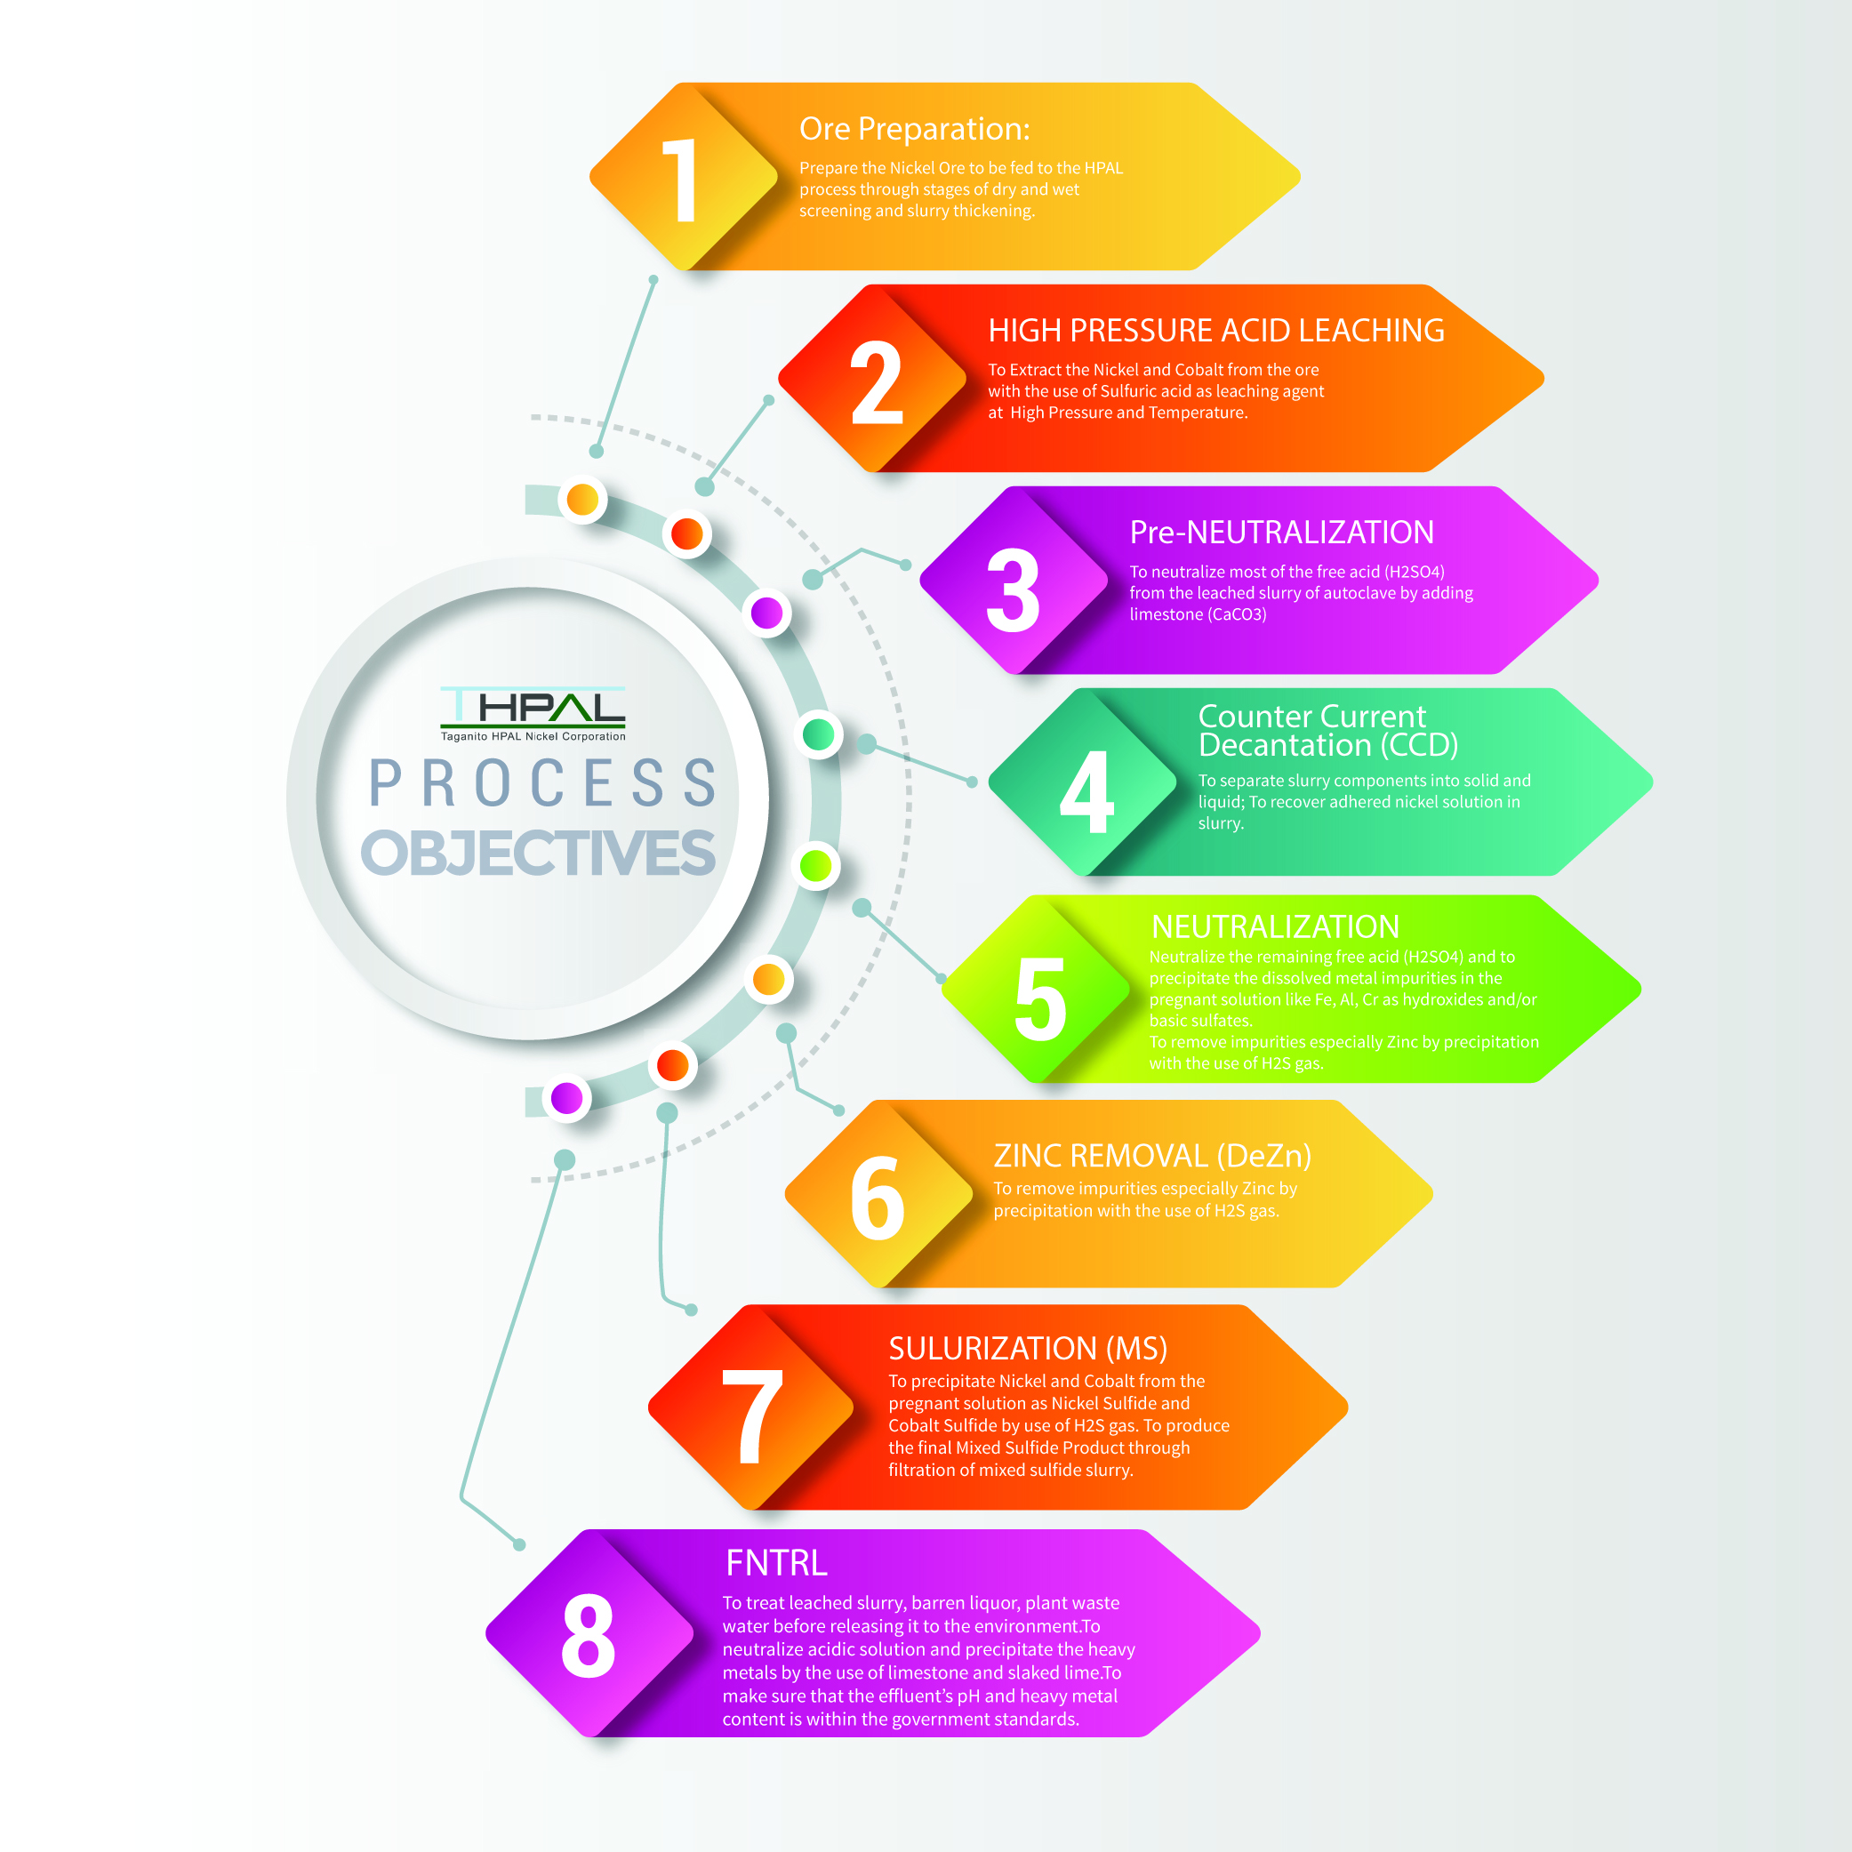

*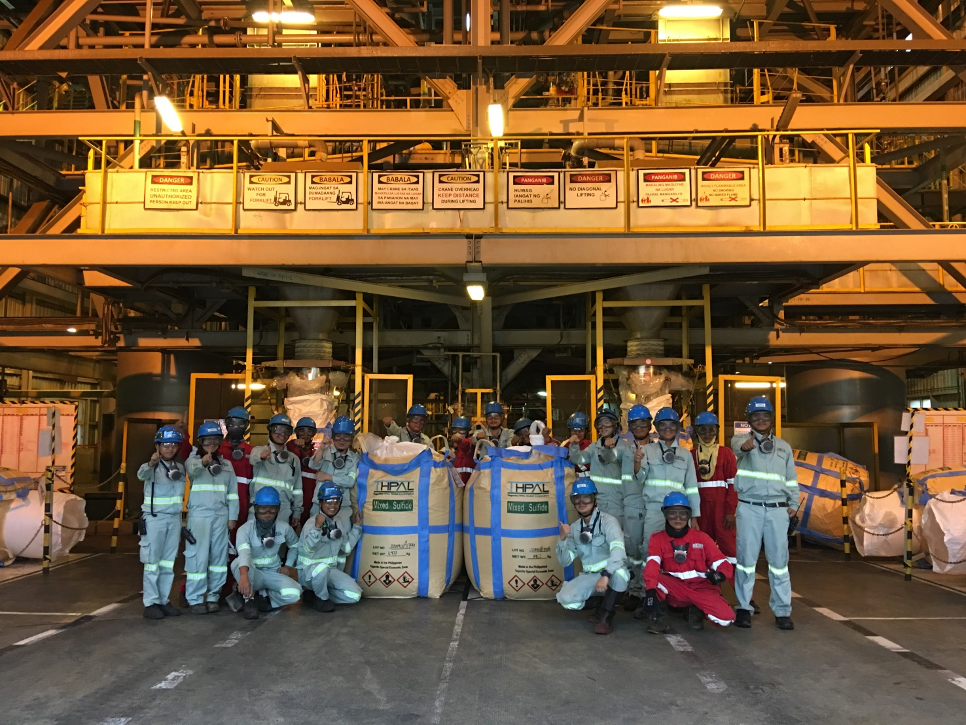“TOGETHER, WE CAN MAKE IT”*

*Engr. Kristelle Lou Ompad*

A celebration is due for hitting the 3500 Dry Ni tons mark target for the first month of the year 2019. This has been the most remarkable of the many accomplishment of the company since its commercial production started. Despite disheartening events the same month the highest monthly production was achieved. It was almost impossible to believe the results. Exasperating polishing filter troubles, fast slaked lime consumption and the previous month’s frustrations to top it all off was what almost thwarted that success. This only shows what collective efforts do. We should continue to practice resilience and solidarity in times of breakdowns and disorders. We’ve already proven it once, and we can always count on it that **TOGETHER**, we can **MAKE IT**.

**OBJECTIVES PER PROCESS AREAS: (Only text, no need to include in the website)**

1. **Ore Preparation:**

Prepare the Nickel Ore to be fed to the HPAL process through stages of dry and wet screening and slurry thickening.

1. **HPAL:**

To Extract the Nickel and Cobalt from the ore with the use of Sulfuric acid as leaching agent at High Pressure and Temperature.

1. **Pre-NTRL:**

To neutralize most of the free acid (H2SO4) from the leached slurry of autoclave by adding limestone (CaCO3)

**4. Counter Current Decantation (CCD):**

To separate slurry components into solid and liquid; To recover adhered nickel solution in slurry.

1. **NTRL:**

Neutralize the remaining free acid (H2SO4) and to precipitate the dissolved metal impurities in the pregnant solution like Fe, Al, Cr as hydroxides and/or basic sulfates.

1. **Zinc Removal (DeZn)**

To remove impurities especially Zinc by precipitation with the use of H2S gas.

1. **Sulfurization (MS):**

To precipitate Nickel and Cobalt from the pregnant solution as Nickel Sulfide and Cobalt Sulfide by use of H2S gas. To produce the final Mixed Sulfide Product through filtration of mixed sulfide slurry.

1. **FNTRL:**

To treat leached slurry, barren liquor, plant waste water before releasing it to the environment.To neutralize acidic solution and precipitate the heavy metals by the use of limestone and slaked lime.To make sure that the effluent’s pH and heavy metal content is within the government standards.